.zip compression
AP Computer Science Principles Name___KEY____

Steps to complete this assignment
- Download the plain text file of Shakespeare's Hamlet from school loop or http://www.gutenberg.org/cache/epub/2265/pg2265.txt
- Open the file in HxD to verify that you can read the text.
- Record the size of the plain text file in the table below
 | Hamlet.txt | OneHello.txt | LotsOfHellos.txt
Size of plain text in KB | 189 | 1 | 4227 (varies)
Size of .zip in KB | 73 | 1 | 10 (varies)
Compression ratio | 61.4% | 0% | 99.7% (varies)

- Compress the plain text file of Hamlet as a .zip file. One way is to right click on the file and choose 7-Zip | Add to archive and then choose zip as the Archive format
- Record the size of the compressed zip file in the table above.
- Calculate the compression ratio. The formula to calculate the compression ratio as a percentage is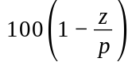 where z is the size of the zip file and p is the size of the plain text file. Record the compression ratio in the table above.
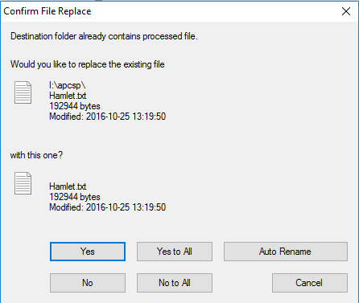
- Use HxD top open the compressed zip file. Can you still read the text? ____No__
- Unzip the compressed file. One way is to right click on the file and choose 7-zip | Extract Here. You should see a warning similar to the one shown. What do you notice about the file sizes?
___zip compression is lossless so the uncompressed file is exactly the same size as the original__
- Create two more plain text files using a program like Notepad. Create the first by typing the word hello once. Save the file as OneHello.txt. Create a second file LotsOfHellos.txt. One way would be type the word hello once. Then choose Ctrl+A to choose all, Ctrl+C to copy and paste after the existing text. After the first time, you will have two hellos. Repeat the process and you will have four hellos. Repeat again, and you will have 8. Keep repeating the process and you will 16, then 32, 64, 128, 256, 512, 1024 or so on. Keep cutting and pasting until your file is at least 100KB in size.
- Compress the two plain text files you created in step 9. Record the uncompressed and compressed sizes and their compression ratios in the table above. What differences in the 3 text files would account for the large differences in the compression ratios? Zip compression works very similarly to the previous text compression lab. The more repetition there is in the words and characters of the file, the smaller the file will be when it is compressed

